**Port Guichon Newsletter**





November Edition

**Dates to Remember:**

* **November 8**

Div. 5 – Delta Museum

6/7 Volleyball Home Game

* **November 10**

Remembrance Day Student Led Program

6/7 Volleyball Home Game

* **November 11**

Remembrance Day

* **November 13 - Sunday**

PAC Winter Market 10:30-3:30

* **November 18**

PAC Hot Lunch

* **November 22**

6/7 Volleyball Tourney – DS

* **November 23**

Nathan Wilson Spirit Canoe

* **November 24**

Div. 1&2 Science World

* **November 25**

PAC Movie Night

* **November 28**

Professional Day

* **November 29**

Div. 1 Skating

* **December 2**

PAC Hot Lunch

* **December 5 - 9**

Food Drive for Deltassist

**Principal’s Message**

The weather outside has quickly turned frightful! The snow was a surprise and fun to play in yesterday. I do like that we have a little more light in the morning to increase visibility as our students get to school. Students have been reminded to be prepared for all weather – inside/outside shoes, toque, mittens, rain jacket, rain pants, dry change of clothes (including socks and underwear) – just in case. It comes in handy once the puddles turn to lakes!

Classroom conversations have been focusing on kindness and respect for self and others lately, as well as being accountable and repairing relationships when mistakes are made. We all know that getting a little less sleep affects our mood. We try to spread kindness since a smile can make a difference in anyone’s day.

We will honour and show respect for our Veterans and Armed Forces service members by participating in our Remembrance Day stations on Thursday. Students are asked to please wear white on top and black (or dark) on bottom to represent a more formal tone for our event. Thank you to Division 1 for leading the learning. We hope that families are able to join us in the gym (the schedule is later in the newsletter). It is wonderful to see the younger students look up to the ‘big buddies’ and connect as a school community.

Have a wonderful Remembrance Day together on Friday. Thank you to Charley and Eddie Sayce for representing Port Guichon Elementary and laying our wreath at the Cenotaph.

We hope to see you at the Winter Market on Sunday. Thank you to our PG PAC for all of the fun family events that have been planned. The school has renewed energy when we are all here together.

Mrs. Palmer

**Remembrance Day Ceremony**



Our Remembrance Day Assembly will be held on November 10th. Please remember to send a donation with your child to school for Remembrance Day. All proceeds go towards the Ladner Legion.

Division 1's amazing class is hosting a presentation for each class separately held on Nov 10th.  Each presentation is 25 minutes.  Parents are being invited to join their children’s class for the walk through at their scheduled times.  Parents can arrive through the front door close to their children's scheduled time. The presentation includes the meaning behind four subjects: The Poppy, Dove, Paper Cranes and Fallen Soldiers along with a video.   
  
9:00 - Div 3   
9:30 - Div 7   
10:00 - Div 4

11:00 - Div 8   
11:30 -  Div 5   
1:00 - Div 6

1:30 - Div 2

**Student Affordability Grant**

The Delta District has access to a grant this year that can help families who are facing financial challenges. If you could use some help, please feel free to reach out to Mrs. Palmer at [dpalmer@deltaschools.ca](mailto:dpalmer@deltaschools.ca) and we may be able to send some help your way. Thank you.

**Volleyball**

Our Grade 6 and 7 students have started the volleyball and participating with the other schools in Ladner on Tuesdays and Thursdays after school. Spectators are welcome to attend and cheer on our teams.

Thanks to those parents who can and have driven for our away games and to our Coaches Ms. Kay and Mr. Jang

There will be a final tournament for the Grade 6/7 Team on Tuesday, November 22nd at Delta Secondary.

**Jersey Call Out**

We are missing a lot of our school sport Jerseys! If you happen to have a PG Jersey at home – please send them back to the school. Thank you for that.

For the first time this year as part of our Spirit Wear – we are going to sell dry fit t-shirts with our school jersey logo. You child will have an opportunity to secure their own Jersey then they can keep.

**Spirit Wear**

We are finalizing details of PG’s Spirit Wear offer. Order Forms will be sent home within a week and Sample sizes will be found at the office soon.

**Spirit Wear Call Out**

Carrying on with the Spirit Wear theme – we are asking if any families have gently used Spirit Wear their children are no longer wearing due to sizing and are willing to donate back to the school. We would then like to make them available to those who may not want to purchase new.

**Clothing at School**

As we proceed into the cold and wet months, it is important that children dress appropriately for the weather, even if they are being driven to and from school. Please remind your child about the importance of bundling up during recess and lunch, as they are sometimes too eager to rush out and play. Also, if possible, please label clothing items for your child

For some children, it would be helpful if they had a change of closes at school (particularly pants, socks and shoes). These items could be used during P.E. classes, as well as when children accidentally get wet during recess or lunch. This prevents the office from having to call parents, asking them to bring a change of clothing.

**Ocean Wise Dome**

We had a great program presented by Ocean Wise for all classes here on November 2nd. There were three stations where our children learned about the important connections between ocean health, climate change, and daily life. The highlight was the portable, inflatable six-metre dome that projects 360-degree 4K cinematic footage.

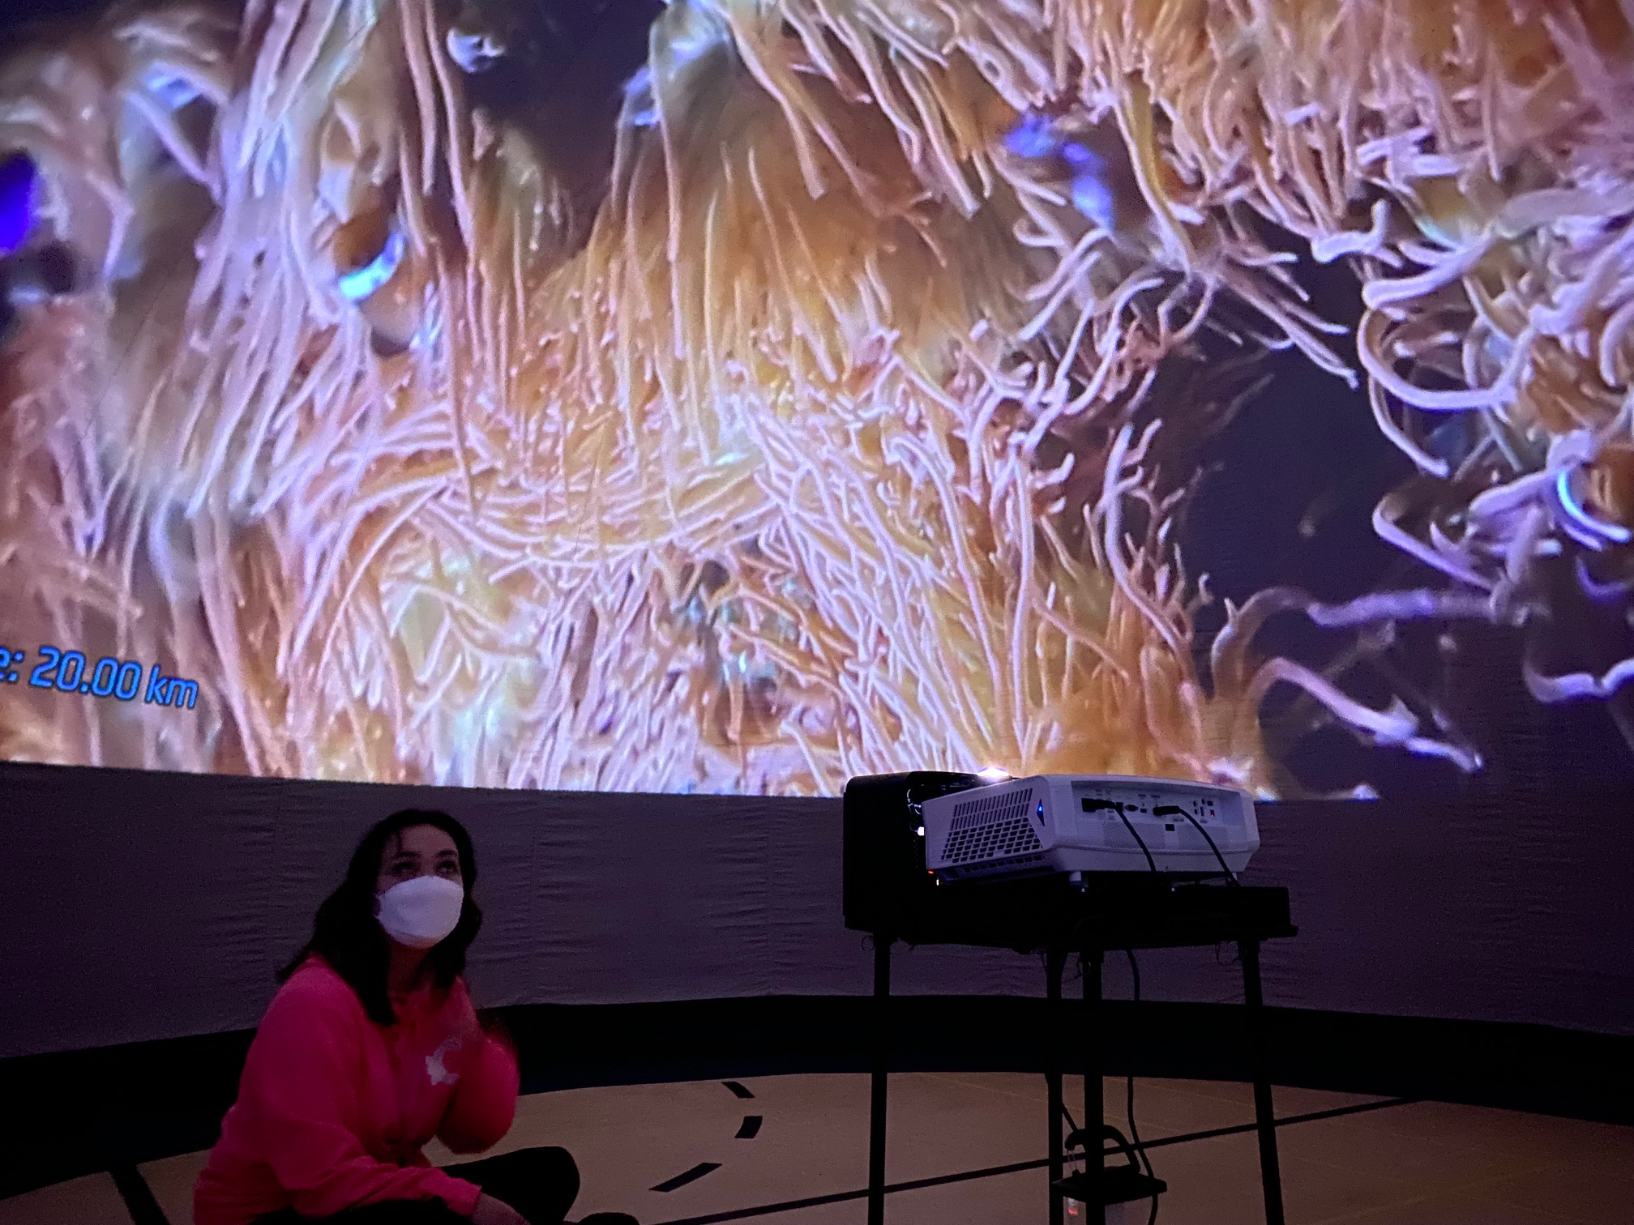

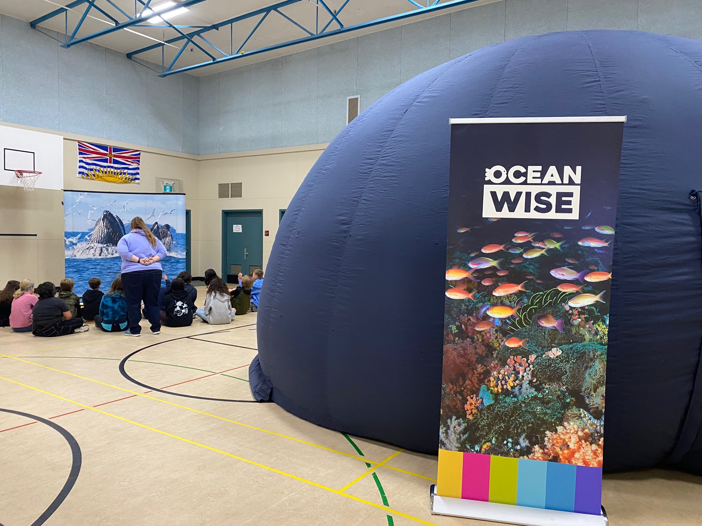

**PAC News**



PAC is running it’s Christmas Purdy’s Fundraiser. On-line order due November 18, 2022 and pick up will be December 5, 2022 at the school. Order code is 20830.

**Winter Fundraise**r Pointsettias, Winter Plants and Greenery – Due November 18th

**Neufeld Fundraiser** – Due November 27, 2022

**FundScrip Gift Cards** – due November 21, 2022

**PAC NEWS**

**Hot Lunch**: PAC is has set up the Hot Lunch Dates and ordering system with the Muncha-a-Lunch program. More information and direct links to order are found on the school website.

**NEXT PAC MEETING**:

The next PAC meeting will be held We Monday, November 21 at 7:00 pm. Hope to see you all there!

**Upcoming Port Guichon PAC Fundraiser**s:

Winter Market, November 13, 2022 – 10am-2pm

Hot Lunches: November 4 & 18

Movie Night: November 25